SIMATS ENGINEERING
ASSESSMENT TOOL 3

COURSE CODE: CSA14 COURSE NAME: Compiler Design

COURSE OUTCOME COVERED

CO1: Apply lexical analysis for token specification and recognition using LEX tool. (BL3)

Assessment Tool Weightage: 10%

QUESTIONS: Total Marks:50

Annexure A

TECHNICAL PRESENTATION

Code of Conduct:

I S.Mahalakshmi (192524372) (Name / Reg No) certify that this submission is my original work and that I have adhered to the guidelines specified for this assessment.
I understand that any violation of academic integrity rules will result in disciplinary action.

Signature of the student:

S.Mahalakshmi

Annexure A

TECHNICAL PRESENTATION

20. Tokens and Lexemes
- Token: category of symbols.
- Lexeme: actual string.
- Example: id, number.
- Essential in parsing.
- Defined using patterns.

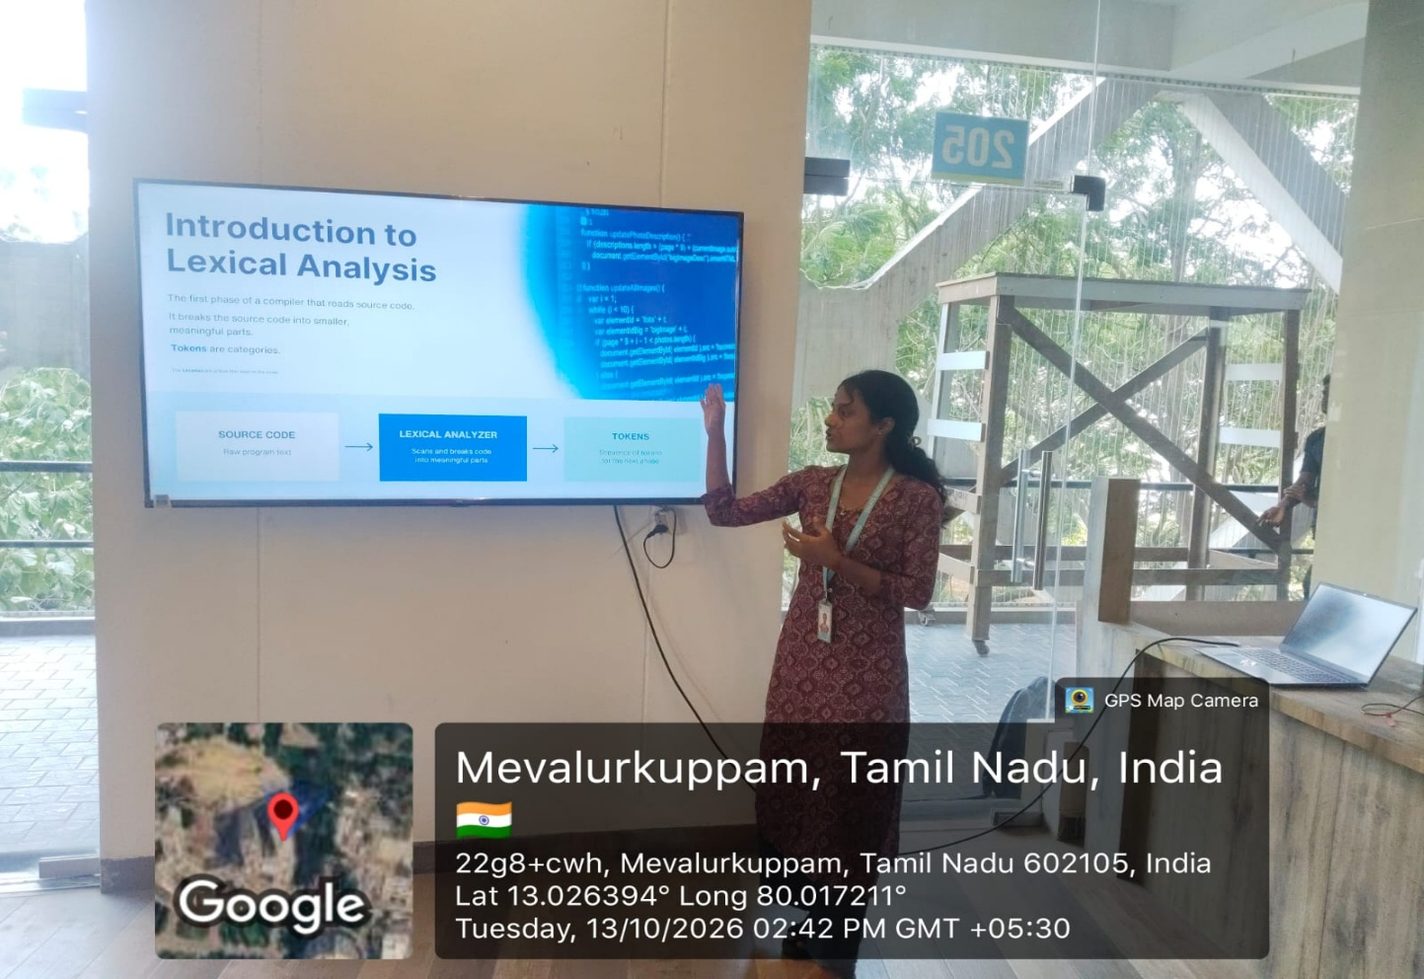

RUBRICS FOR CALCULATION:

Criteria | Weightage | Level 4 – Exemplary | Level 3 – Proficient | Level 2 – Developing | Level 1 – Beginning
Understanding of Case | 25 | Thorough understanding; clearly identifies all key issues | Good understanding with most issues identified | Basic understanding; some issues missed | Poor understanding; problem not identified correctly
Application of Concepts | 25 | Effectively applies relevant concepts to analyze the case deeply | Applies appropriate concepts with minor gaps | Limited application of concepts | Fails to apply relevant concepts
Analysis | 20 | In-depth analysis with strong reasoning and insights | Good analysis with logical reasoning | Basic analysis with limited depth | Weak or no analysis; lacks reasoning
Solution Design | 20 | Innovative, feasible solutions with strong justification | Logical solutions with adequate justification | Basic solutions with weak justification | Incorrect or no solution provided
Clarity | 10 | Clear, well-structured, and easy to understand | Organized and understandable presentation | Limited clarity and structure | Poor clarity; difficult to understand

